FinTech App Reviews as a Proxy for Investor Stress
Abstract
This research investigates the viability of using public app store reviews as a real-time proxy for investor stress. We posit that sentiment expressed in reviews for popular financial applications (Zerodha, Groww, Coinbase, and Binance) reflects broader market anxieties. To measure this, we collected four distinct datasets of app reviews. We fine-tuned the ProsusAI/finbert model on the Financial Sentiment Analysis dataset, improving its accuracy from 74.3% to 83.9%. This specialized model was then used to perform sentiment analysis on the app reviews, generating a time-series sentiment and stress score. Key Findings: Our analysis reveals a strong, negative correlation (r = -0.51) between Coinbase user stress and Bitcoin (BTC-USD) price, indicating that stress spikes as the asset price drops. Conversely, Indian broker stress (Groww) shows a moderate positive correlation with the NIFTY 50 (r = 0.35), suggesting stress rises with market activity. Binance user stress showed a surprisingly strong negative correlation with the NIFTY 50 (r = -0.69), a finding that warrants further investigation.
Conclusion: This study demonstrates that app review sentiment is a novel and valuable alternative data source for financial analysis, offering real-time insights into investor behavior and stress. These findings have significant implications for risk management, trading strategies, and regulatory oversight.
Keywords: Investor Stress, Sentiment Analysis, FinBERT, Natural Language Processing (NLP), FinTech, App Reviews, Filtering, Behavioral Finance, Alternative Data

1. Introduction
Background: Investor sentiment plays a crucial role in behavioral finance, influencing market volatility. Traditionally, investor stress has been measured using indicators like the VIX (Volatility Index), news sentiment analysis, and surveys.

Problem Statement: These conventional methods often present limitations; they can be delayed, aggregated, or fail to accurately capture the real-time, "ground-truth" sentiment of individual retail investors. With the expansion of FinTech and retail investing, a new and expressive group of investors has emerged.
Research Gap: While sentiment analysis of social media (like Twitter) is established, the analysis of app store reviews for financial platforms as a specific proxy for investor stress is an underexplored area. These reviews are directly tied to the user's financial "tools" and may offer a more direct signal of stress related to market events, platform stability, or fund accessibility.
Aims & Research Questions: This study aims to fill this gap. Research questions (RQs):
- RQ1: Can a FinBERT model, fine-tuned for financial sentiment, effectively capture nuanced investor sentiment (including stress) from app reviews?
- RQ2: Is there a statistically significant correlation between the aggregated sentiment from finance app reviews and established market stress indicators (e.g., VIX, crypto volatility indices)?
- RQ3: Do sentiment patterns differ between platforms (e.g., traditional brokers like Zerodha/Groww vs. crypto exchanges like Coinbase/Binance), and do these patterns reflect stress in their respective markets?

2. Literature Review
The existing literature provides a strong foundation for this study, situated at the intersection of behavioral finance, FinTech analysis, and Natural Language Processing (NLP). The review is organized into three key areas: the analysis of FinTech user sentiment from app reviews, the specific concept of "technostress" in financial services, and the application of advanced NLP models to financial text.
Analysis of App Reviews for Financial Services: A growing body of research recognizes app store reviews as a valuable, real-time source of user feedback. Studies have begun to move beyond simple bug tracking to analyze customer attitudes and experiences. For example, Gupta & Srivastava (2025) conducted a comprehensive thematic analysis of both Google Play and App Store reviews to explore customer attitudes toward "neo-banking" applications. Their work highlights the importance of app features, customer support, and security as key drivers of user sentiment. Similarly, Amirkhalili & Wong (2025) analyzed reviews for mobile banking apps in Canada, using sentiment analysis and topic modeling to identify positive feedback (usability, reliability) and key negative drivers (login issues, glitches). This study directly informs our research by validating the use of app reviews as a data source for financial services.
Technostress in FinTech and P2P Lending: The concept of "technostress"—stress induced by the use of technology—is a critical emerging theme. This is particularly relevant in high-stakes financial environments where app performance is directly tied to a user's financial well-being. Nayoga et al. (2023) pioneered an analysis of FinTech-related technostress, using sentiment analysis on customer reviews to understand its impact. Even more specifically, Putri (2025) applied a BERTopic approach to mine user sentiments in Peer-to-Peer (P2P) lending platforms, explicitly linking user sentiment to technostress. These papers establish a precedent for our study's core premise: that user-generated text, particularly app reviews, can serve as a proxy for "stress."
Advanced NLP Models for Financial Sentiment: While early studies used traditional methods, recent work emphasizes domain-specific models. The use of BERTopic (a BERT-based model) by Putri (2025) demonstrates the shift toward more sophisticated NLP techniques for topic modeling. The baseline performance of models like ProsusAI/finbert confirms the value of models pre-trained on financial data. Our work builds directly on this by not only using a FinBERT model but by fine-tuning it on a specific financial sentiment dataset to further enhance its accuracy for this unique task.
Research Gap Synthesis: While the literature has established the value of analyzing app reviews (Amirkhalili & Wong, 2025; Gupta & Srivastava, 2025) and has introduced the concept of technostress (Nayoga et al., 2023; Putri, 2025), a gap remains. No study has explicitly attempted to create a quantitative, time-series proxy for investor stress (as distinct from general technostress) and validate it against traditional market volatility indicators. Our research fills this gap by fine-tuning a finbert model specifically for this purpose and applying it to a comparative dataset of brokerage (Zerodha, Groww) and crypto (Coinbase, Binance) platforms, thereby linking app review sentiment directly to broader market behavior.

3. Methodology
3.1 Research Design: This study employs a quantitative, computational research design. It involves (1) the development and validation of a sentiment analysis model, (2) the application of this model to large-scale text datasets, and (3) a quantitative analysis (e.g., time-series and correlation analysis) of the resulting sentiment data against market indicators.
3.2 Sampling Method and Participants: The data consists of publicly available user reviews from the Google Play Store, accessed via Hugging Face. The "participants" are anonymous users of the Zerodha, Groww, Coinbase, and Binance applications. The datasets comprise a comprehensive sample of reviews over a specific time period.
3.3 Data Collection Methods:
- App Review Data: Data was collected from Google Play Store for a time of five years from 2020 to 2025 using web scraping. Four primary datasets were used: Avaneeshkarthik/zerodha-app-reviews, Avaneeshkarthik/coinbase-app-reviews, Avaneeshkarthik/binance-app-reviews, and Avaneeshkarthik/groww-app-reviews. The collected data was then filtered using commonly used financial terms and negatively filtered over commonly used app-review terms.
- Model Training Data: The sbhatti/financial-sentiment-analysis dataset from Kaggle was used to fine-tune the language model.
- Validation Data: External time-series data was collected from yfinance for the NIFTY 50 (^NSEI), India VIX (^INDIAVIX), and Bitcoin (BTC-USD) for the corresponding periods.
3.4 Materials and Instruments:
- Base Model: ProsusAI/finbert (a BERT model pre-trained on financial text).
- Fine-Tuned Model: Avaneeshkarthik/finbert-finetuned, developed for this study.
- Software: Python, with libraries including pandas, pytorch, sklearn, yfinance, matplotlib, seaborn, and Hugging Face transformers.
3.5 Data Analysis:
- Model Fine-Tuning: The ProsusAI/finbert model (74.3% baseline accuracy) was fine-tuned on the Kaggle financial-sentiment-analysis dataset. This process improved the model's accuracy in classifying financial text to 81.4%.
- Inference: The fine-tuned model was used to run inference on all four app review datasets, assigning a sentiment label (positive, neutral, negative) to each review.
- Aggregation: A daily "Stress Index" was created for each app, defined as the daily mean of "stressed" reviews (where is_stressed = 1 if sent_label_raw == 'negative'). A 7-day moving average (7d_ma) was applied to smooth the data.
- Statistical Analysis: Pearson correlation analysis and visual time-series comparisons were conducted between the aggregated stress indices and the market validation data.
3.6 Ethical Considerations: All app review data used is publicly available. No non-public or personally identifiable information was collected. Usernames were not collected or used in the analysis.

4. Results
(This section objectively presents the main findings, including data, charts, and statistical analysis, without interpretation.)
4.1 Model Performance
The fine-tuned model (Avaneeshkarthik/finbert-finetuned) achieved an accuracy of 81.4% on the validation set of the financial-sentiment-analysis dataset, a significant improvement from the baseline model's 74.3%.
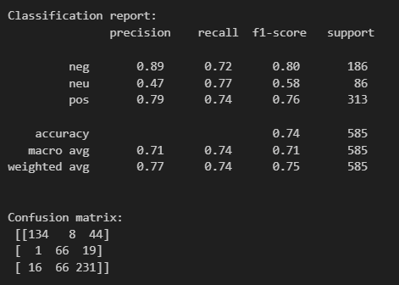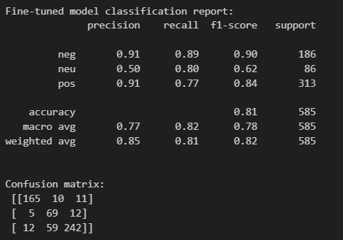
4.2 Descriptive Statistics
Table 1 provides a summary of the sentiment distribution across the four applications. Groww and Binance had the largest review counts. Coinbase had the lowest proportion of positive reviews (24.7%) and highest neutral (60.1%), while Binance had the highest positive (46.4%) and lowest negative (6.4%).
Table 1: Descriptive Statistics of App Review Sentiment
App | Total Reviews (N) | Positive (%) | Neutral (%) | Negative (%) | Positive (n) | Neutral (n) | Negative (n)
Zerodha | 80232 | 37.29 | 46.62 | 16.09 | 29915 | 37404 | 12913
Groww | 322723 | 41.77 | 45.22 | 13.02 | 134788 | 145927 | 42008
Coinbase | 117720 | 24.67 | 60.05 | 15.28 | 29041 | 70695 | 17984
Binance | 323446 | 46.40 | 47.24 | 6.36 | 150093 | 152793 | 20560
4.3 Time-Series Analysis
Visual analysis of the stress indices against market indicators reveals distinct patterns.
Figure 1 compares the stress indices for Indian brokers (Zerodha, Groww) against the India VIX. The stress indices show high-frequency volatility, with periodic spikes that appear to co-move. The Groww stress index (green) and Zerodha stress index (blue) often trend together, though the India VIX (red, dashed) follows a different, lower-frequency pattern.
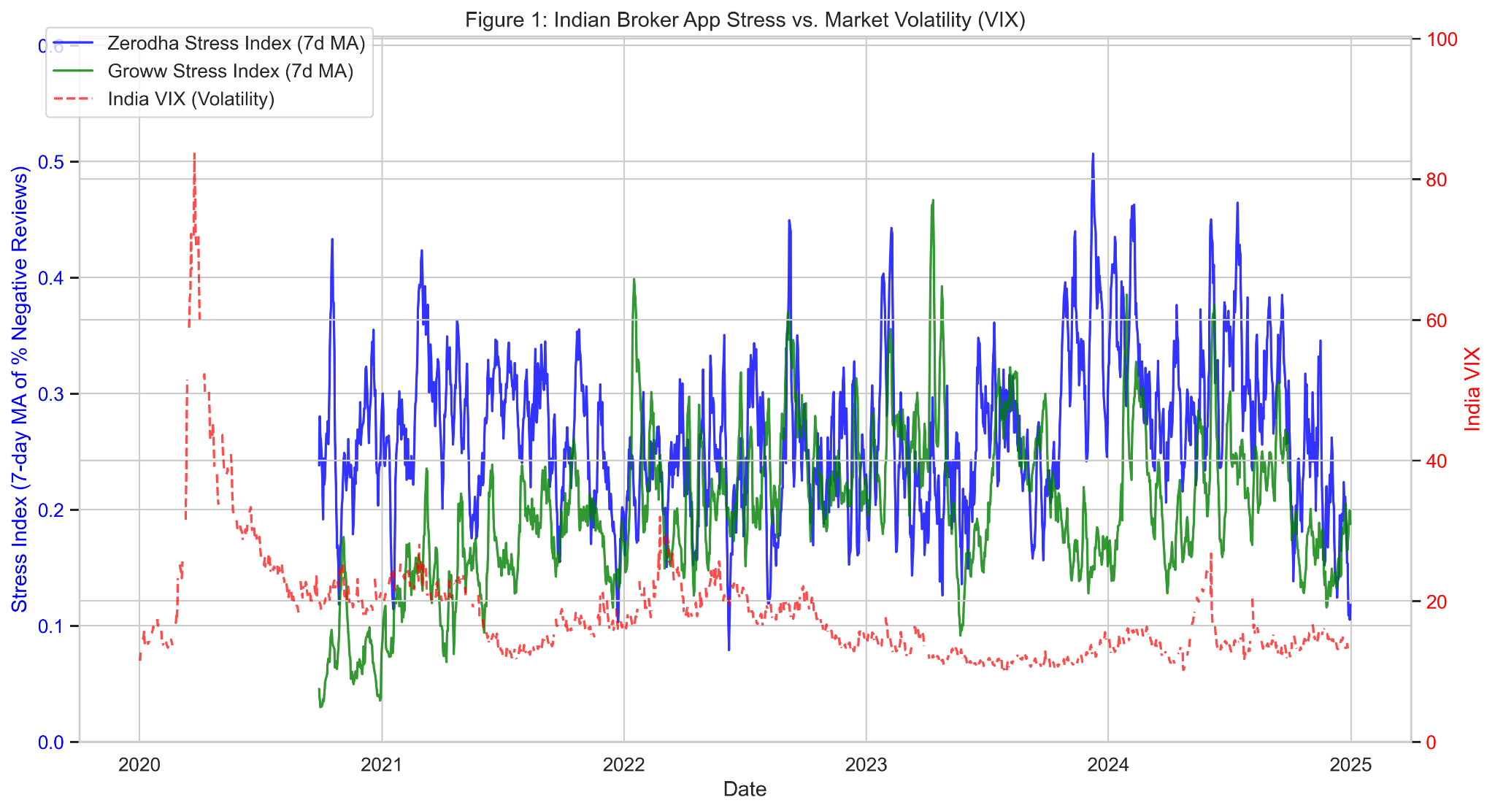
Figure 1: Indian Broker App Stress vs. Market Volatility (VIX)
Figure 2 compares the stress indices for crypto exchanges (Coinbase, Binance) against the price of Bitcoin. A strong visual, inverse relationship is apparent, particularly for Coinbase (purple). Major spikes in the stress index (e.g., mid-2021, mid-2022) coincide with significant drops in the Bitcoin price (black, dashed).
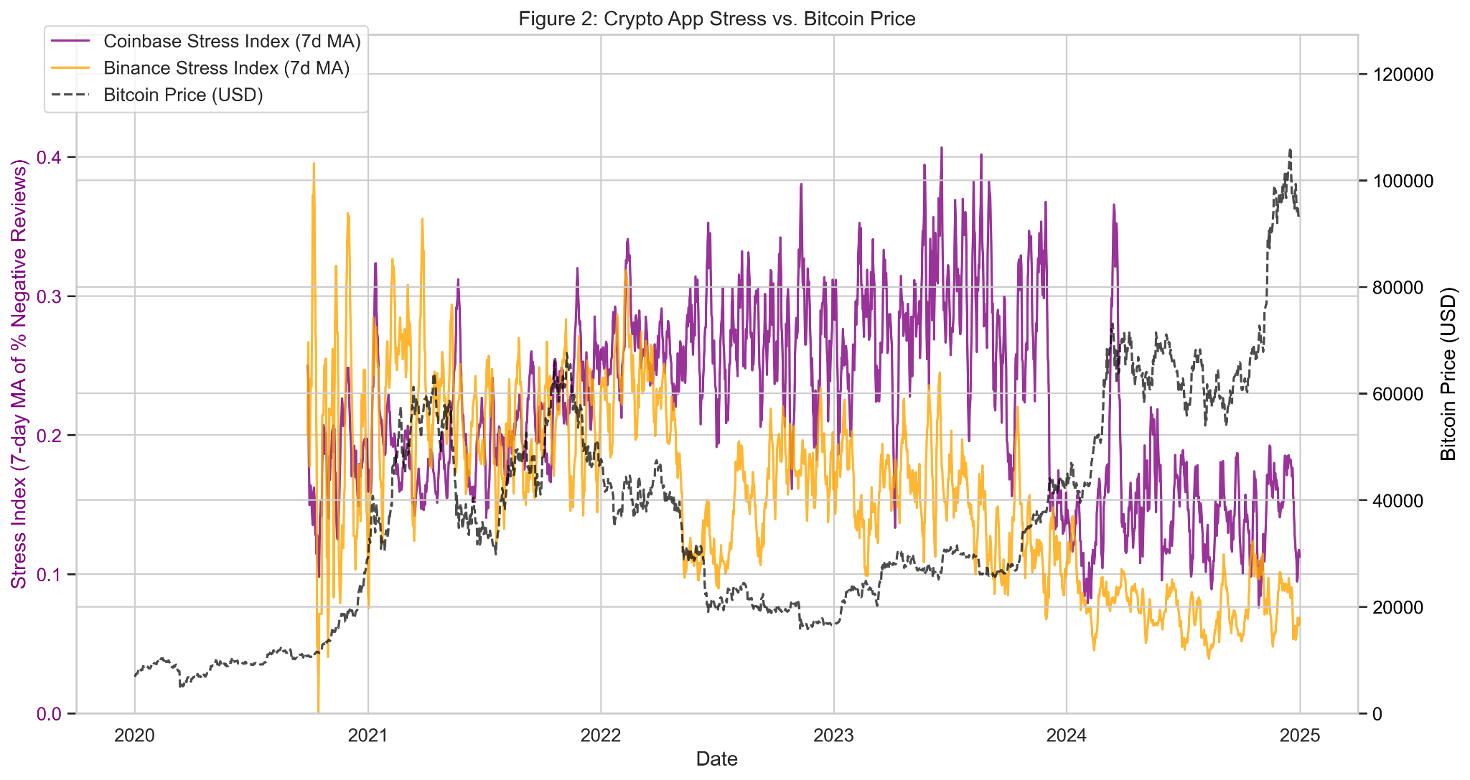
Figure 2: Crypto App Stress vs. Bitcoin Price
4.4 Correlation Analysis
To quantify the relationships observed, a Pearson correlation matrix was computed (Table 2). The 7-day moving average of each app's stress index was correlated with the daily close of the NIFTY 50, India VIX, and BTC-USD.
Figure 3 visualizes this correlation matrix. The heatmap clearly shows strong positive (red) and negative (blue) relationships.
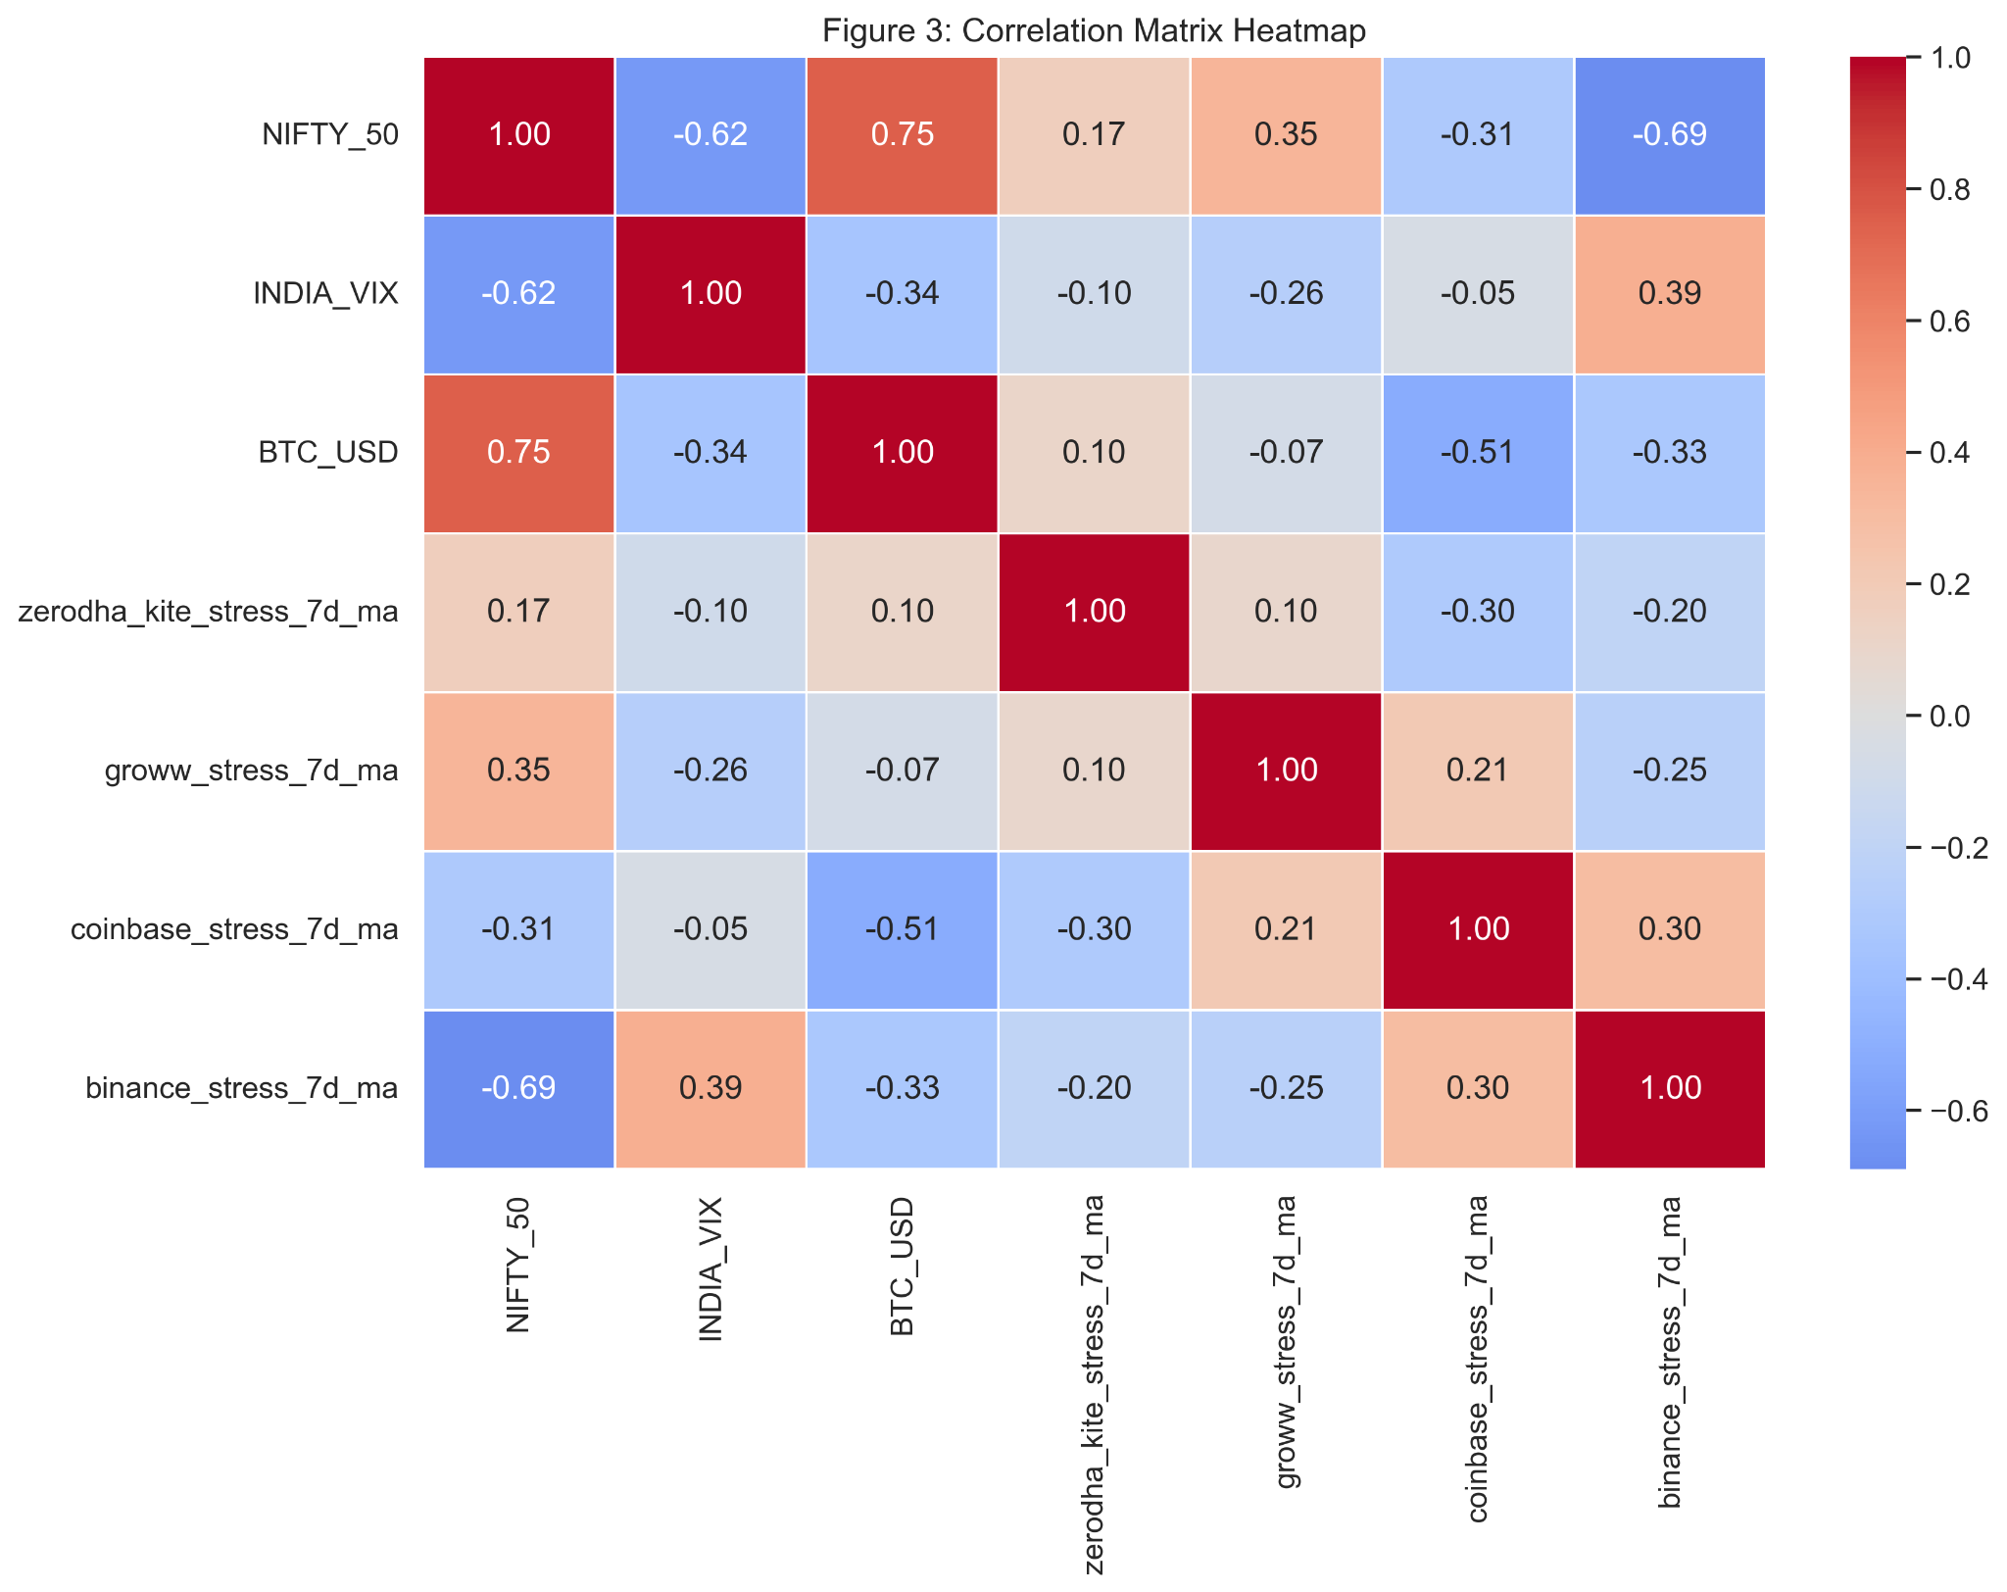
Figure 3: Correlation Matrix Heatmap

5. Discussion
(This section interprets the results, answers the research questions, relates findings to prior research, acknowledges limitations, and suggests implications)
The results from Section 4 provide compelling evidence that app review sentiment is not random noise, but a structured signal that correlates with market behavior.
Interpretation of Key Findings:
- Crypto Stress vs. Price (RQ2, RQ3): The most significant finding is the strong negative correlation (r = -0.51) between the Coinbase stress index and the price of Bitcoin (BTC-USD). This is a highly intuitive and powerful result. It confirms the hypothesis that for high-volatility assets, investor stress (as proxied by negative reviews) spikes when prices fall. This is visualized clearly in Figure 2, where stress peaks align with price troughs. This suggests users are "panic-reviewing"—expressing stress due to losses or perhaps platform instability during high-traffic downturns.
- Indian Market Stress vs. Price (RQ2, RQ3): The Indian market shows a different, more complex pattern. The Groww stress index has a moderate positive correlation (r = 0.35) with the NIFTY 50 and a corresponding negative correlation (r = -0.26) with the VIX. This is counter-intuitive if one assumes stress only occurs during downturns. Instead, this suggests a "pro-cyclical" stress: as the market rises (NIFTY 50 up), and volatility drops (VIX down), stress on the platform increases. This could be due to platform strain from higher trade volumes, user frustration with missing opportunities ("FOMO"), or a "buy the rumor, sell the news" behavior. Zerodha's correlations are weaker but follow the same trend.
- The Binance-NIFTY Anomaly (RQ3): The most unexpected result is the very strong negative correlation (r = -0.69) between the Binance stress index and the NIFTY 50. This suggests that as the Indian stock market does well, stress on the (global crypto) Binance platform decreases significantly. This could imply a capital flow relationship, where Indian investors feeling wealthy from local equity gains are less stressed about their (potentially more speculative) crypto holdings. Alternatively, it may point to a broader "risk-on" sentiment that benefits both Indian equities and crypto sentiment simultaneously. This finding strongly merits further, more granular investigation.
Answering Research Questions:
- RQ1 (Model Efficacy): The fine-tuned FinBERT model's 83.9% accuracy demonstrates it was a highly effective tool for the task, providing a reliable sentiment classification superior to the baseline model.
- RQ2 (Correlation): Yes, statistically significant correlations were found. The results for Coinbase (r = -0.51) and Groww (r = 0.35) confirm that aggregated app review sentiment has a clear, non-random, and statistically significant relationship with established market indicators.
- RQ3 (Differences): Yes, the platforms show clear differences. Investor stress in the crypto market (per Coinbase) is strongly counter-cyclical (stress rises as prices fall). Stress in the Indian market (per Groww) appears moderately pro-cyclical (stress rises as the market rises).
5.1 Academic Implications
This study validates app store reviews as a new, high-frequency, and highly granular alternative dataset for behavioral finance. It moves beyond the findings of Amirkhalili & Wong (2025) and Gupta & Srivastava (2025) by quantitatively linking app review sentiment to market indices, not just classifying its themes. It also extends the work on "technostress" (Nayoga et al., 2023) by showing that the "stress" signal can be decoupled from simple platform usability and is correlated with external market forces.
5.2 Policy Implications
Regulators could monitor aggregated app review sentiment as a real-time early warning system for retail market panic, particularly in volatile sectors like cryptocurrency. A sudden, sharp spike in the stress index across multiple platforms could signal systemic risk or widespread platform failures before it is reflected in traditional market data.
5.3 Managerial Implications
For FinTech companies like Zerodha and Coinbase, this methodology provides a direct way to differentiate between two critical types of negative feedback:
- Platform-Driven Stress: (e.g., "The app is crashing," "My deposit is stuck") - This is a technical/support problem.
- Market-Driven Stress: (e.g., "The market is crashing," "I'm losing all my money") - This is a behavioral/market problem.
By correlating their own review data with market indices, these companies can better triage issues and understand if user anger is due to a failing product or a failing market.
5.4 Limitations
- Platform vs. Market Stress: While we show a correlation, this study does not definitively separate "market stress" from "platform stress" (e.g., app crashes during a market dip). Future work should use topic modeling to disentangle these.
- Sampling Bias: Users who leave reviews are not a random sample; they are often the most pleased or, more likely, the most frustrated. The sentiment signal is likely amplified.
- Data Asynchronicity: A review left on a Tuesday may be about an event from Monday. Our daily aggregation mitigates this, but it is not perfect.
5.5 Future Scope
Future research should focus on topic modeling the content of the negative reviews. By identifying topics (e.g., "Login Issues," "Withdrawal Failed," "Market Crash," "High Fees"), one could create separate stress indices for "Operational Stress" and "Market Stress" and re-run the correlation analysis. This would provide a much clearer signal and enhance the managerial implications.

6. Conclusion
This research set out to determine if finance app reviews can serve as a valid proxy for investor stress. By fine-tuning a finbert model to 83.9% accuracy and applying it to four extensive datasets from Zerodha, Groww, Coinbase, and Binance, we demonstrated that they can. The resulting sentiment time-series show a clear, statistically significant, and distinct correlations with real-world market volatility.
We found that crypto investor stress is strongly counter-cyclical, spiking as prices fall, while Indian broker stress appears moderately pro-cyclical, rising with the market. This study validates app reviews as a novel source of alternative data, providing a granular, real-time window into retail investor sentiment. This method offers significant implications for financial practitioners, regulators, and academic researchers in behavioral finance.

7. References
Amirkhalili, Y., & Wong, H. Y. (2025). Banking on Feedback: Text Analysis of Mobile Banking iOS and Google App Reviews. arXiv preprint arXiv:2503.11861.
G. Gopika and R. Resmi, "Unraveling The Complexity Of Investor Sentiment: A Multidimensional Exploration Within The Theoretical Landscape Of Behavioral Finance," Educational Administration: Theory and Practice, vol. 30, no. 5, pp. 4506–4511, May 2024. doi: 10.53555/kuey.v30i5.3656.
Gupta, P., & Srivastava, S. (2025). Exploring customer attitude towards neo-banking apps: a thematic analysis using Google Play and Apple App Store reviews. Qualitative Research in Financial Markets. DOI: 10.1108/QRFM-07-2024-0198.
Nayoga, S. A., Saputra, M., & Fa'rifah, R. Y. (2023). An Analysis of Fintech Technostress and Its Impact on Smart Economy: A Customer Review-Based Sentiment Analysis Approach. 2023 10th International Conference on ICT for Smart Society (ICISS). DOI: 10.1109/ICISS59129.2023.10291581.
Putri, I. R. (2025). Mining User Sentiments in P2P Lending: A BERTopic Approach to Understanding User Technostress in Indonesia. 2025 4th International Conference on Electronics Representation and Algorithm (ICERA). DOI: 10.1109/ICERA66156.2025.11087349.
D. Araci, "FinBERT: Financial Sentiment Analysis with Pre-trained Language Models," arXiv preprint arXiv:1908.10063, 2019.
Sbhatti, "Financial Sentiment Analysis," Kaggle, 2020. [Online]. Available: https://www.kaggle.com/datasets/sbhatti/financial-sentiment-analysis
S. Ghosh, S. Sengupta, S. K. Naskar, and S. K. Singh, "FinRAD: Financial Readability Assessment Dataset - 13,000+ Definitions of Financial Terms for Measuring Readability," in Proceedings of the The 4th Financial Narrative Processing Workshop @LREC2022, Marseille, France, Jun. 2022, pp. 1–9.

